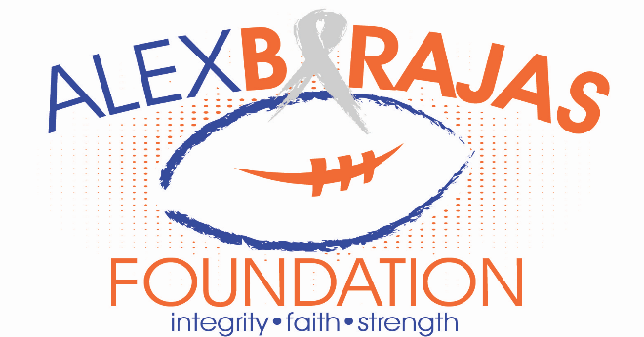
7th Annual Alex Barajas 5K Run/Walk and Silent Auction
Saturday, January 20, 2018 @ 8 am
All proceeds will benefit the Alex Barajas Foundation to raise money for cancer research and a college scholarship.
RACE SITE: Lake Placid Christian School, 148 E. Interlake Blvd., Lake Placid, FL 33852
MAKE CHECKS PAYABLE & SEND TO: Alex Barajas Foundation, 1008 Burnett St., Lake Placid, FL 33852. You may also drop registrations off at the Blueberry Patch. elviabarajas24@gmail.com
------------------------------------------------------------------------------------------------------------------------ 2018 ALEX BARAJAS FOUNDATION 5K Run/Walk Registration

Last Name: _____First Name: ____________
Gender___ Address: __City: _______
State: ___ Zip: ________Phone: ______________Age as of 1/20/18:____

In consideration of this entry being accepted, I hereby for myself, heirs, executers and administrators waive and release all rights and claims that for damages which may hereafter accrue to me against the Alex Barajas Foundation or any of the sponsors involved in the 5K event. If I would suffer an injury or illness, I authorize the officials of the race to have me transported to a medical facility, and I take full responsibility for this action. I certify that I and those I am registering are physically able to participate in the event. I have read the above release and understand that I am entering this event at my own risk.

Signature: Date: _________

T-shirt Size:_________ $25 Registration___ $10 Registration no shirt ___
Late registration fee after 1/12/18 $30 and no shirt

You may purchase additional short sleeve race t-shirts for $15 each. They are available in the following sizes: Adult S, M, L, XL, XXL and Children’s S, M, L. Please, list additional number of t-shirts and sizes below. Please order me ____extra shirts in the size(s): _________@ $15 each

Amount Enclosed: _______

